**Lab**

**Raspberry Pi Setup**

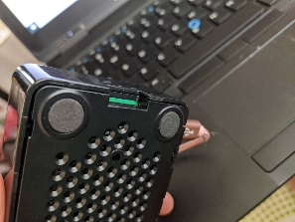Mos of your microSD cards are already loaded with the OS; if you would like to practice doing it yourself, take the microSD card out and create an OS image yourself, here are the steps:

1. 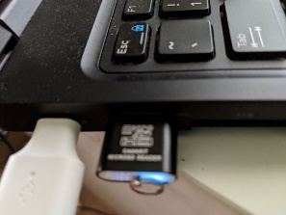Take out he microSD card from its slot:
2. Place the microSD in the microSD reader and connect microSD reader to your computer/laptop:
3. Visit <https://www.raspberrypi.org/software/>
4. Watch this video:

<https://www.youtube.com/watch?v=ntaXWS8Lk34>

Use Ctrl+shift+X to set the WiFi SSID + pass, also enable SSH (put in the public key), and set the host name.

1. Note: you can connect your Raspberry Pi to your TV set with your regular HDMI cable
2. There are other ways to set up wireless without connecting to a monitor ([headless setup](https://www.raspberrypi.org/documentation/configuration/wireless/headless.md)) go to the Boot folder, create this file: ssh(with no extension or content), also create wpa_supplicant.conf and edit it Notepad:

ctrl_interface=DIR=/var/run/wpa_supplicant GROUP=netdev

update_config=1

country=US

network={

ssid="WiFi SSID"

psk="WPA/WPA2 passphrase"

key_mgmt=WPA-PSK

}